WEEK 5 - ReactJS Hands ON

Exercise 1

Create myfirstreact app and display 'Welcome to the first session of React'.

Commands
- npm install -g create-react-app
- npx create-react-app myfirstreact
- cd myfirstreact
- npm start

Solution:
function App() {
return <h1>Welcome to the first session of React</h1>;
}
export default App;
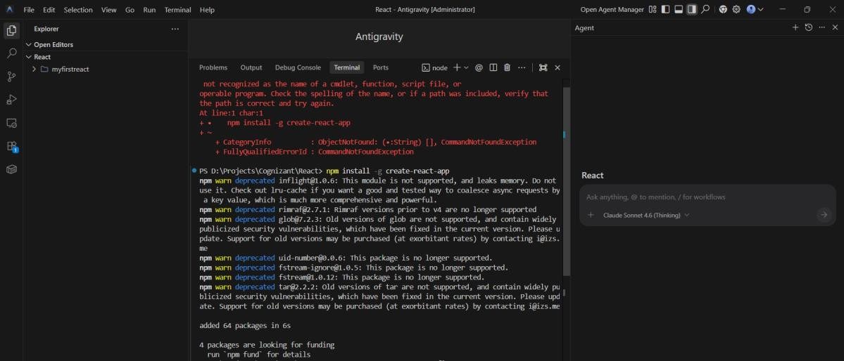

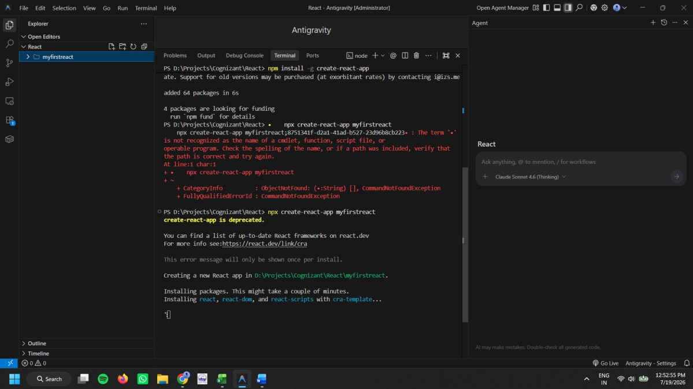

Exercise 2

Class Components
Aim:
StudentApp with Home, About and Contact components.

Commands
- npx create-react-app StudentApp
- cd StudentApp
- npm start

Sample Code
// Home.js
import React,{Component} from 'react'; export default class Home extends Component{
render(){
return <h3>Welcome to the Home Page of Student Management Portal</h3>;
}
}

Exercise 3

Functional Components
Aim:
Score Calculator using props and CSS.

Commands
- npx create-react-app scorecalculatorapp
- npm start

Sample Code
export function CalculateScore({Name,School,total,goal}){ const score=((total/goal).toFixed(2));
return (
<div>
<h1>Student Details</h1>
<p>Name: {Name}</p>
<p>School: {School}</p>
<p>Total: {total}</p>
<p>Score: {score}%</p>
</div>
);
}

Exercise 4 Lifecycle Methods Aim:
Create a React application that fetches blog posts using componentDidMount() and handles errors using componentDidCatch().

Commands
  - npx create-react-app blogapp
  - cd blogapp
  - npm start

Post.js
class Post {

constructor(id, title, body) { this.id = id;
this.title = title; this.body = body;
}
}

export default Post;

Posts.js
import React, { Component } from "react"; import Post from "./Post";

class Posts extends Component { constructor(props) { super(props);
this.state = { posts: [] };
}

loadPosts() { fetch("https://jsonplaceholder.typicode.com/posts")
.then((res) => res.json())
.then((data) => {
const posts = data.map(
(item) => new Post(item.id, item.title, item.body)
);
this.setState({ posts });

});
}

componentDidMount() { this.loadPosts();
}

componentDidCatch(error) { alert("Something went wrong!"); console.log(error);
}

render() { return (
<div>
<h1>Blog Posts</h1>
{this.state.posts.map((post) => (
<div key={post.id}>
<h3>{post.title}</h3>
<p>{post.body}</p>
<hr />
</div>
))}
</div>
);
}

}

export default Posts;

App.js
import Posts from "./Posts";

function App() { return <Posts />;
}

export default App;

Exercise 5
CSS Modules & Styling Aim
Style the React application using CSS Modules. Create a CohortDetails.module.css file and apply styles to display ongoing and completed cohorts.

Commands npm install npm start

Folder Structure
src
│
├── App.js
├── CohortDetails.js

├── CohortDetails.module.css
└── index.js

CohortDetails.module.css
.box {
width: 300px; display: inline-block; margin: 10px; padding: 10px 20px;
border: 1px solid black; border-radius: 10px;
}

dt {
font-weight: 500;
}

CohortDetails.js
import styles from "./CohortDetails.module.css";

function CohortDetails(props) {

return (

<div className={styles.box}>

<h3
style={{ color:
props.status === "ongoing"
? "green"
: "blue"
}}
>
{props.name}
</h3>

<dl>

<dt>Started On</dt>
<dd>{props.startDate}</dd>

<dt>Current Status</dt>
<dd>{props.status}</dd>

<dt>Coach</dt>
<dd>{props.coach}</dd>

<dt>Trainer</dt>
<dd>{props.trainer}</dd>

</dl>

</div>

);

}

export default CohortDetails;

App.js
import CohortDetails from "./CohortDetails";

function App() {

return (

<div>

<h1>My Academy Cohorts</h1>

<CohortDetails name="React JS" startDate="10-Jan-2025" status="ongoing" coach="John" trainer="David"

/>

<CohortDetails name="Java Full Stack"
startDate="15-Dec-2024" status="completed" coach="Smith" trainer="Alex"
/>

<CohortDetails name="Python" startDate="20-Feb-2025" status="ongoing" coach="Emma" trainer="Sophia"
/>

</div>

);

}

export default App;

index.js
import React from "react";
import ReactDOM from "react-dom/client"; import App from "./App";

const root = ReactDOM.createRoot( document.getElementById("root")
);

root.render(
<React.StrictMode>
<App />
</React.StrictMode>
);

